



# Introduction

*[Short introduction about overall business scenario and the user scenarios you are covering]*

# User Scenarios

## [User Scenario 1]

*[Microservice Interaction Diagram]*

*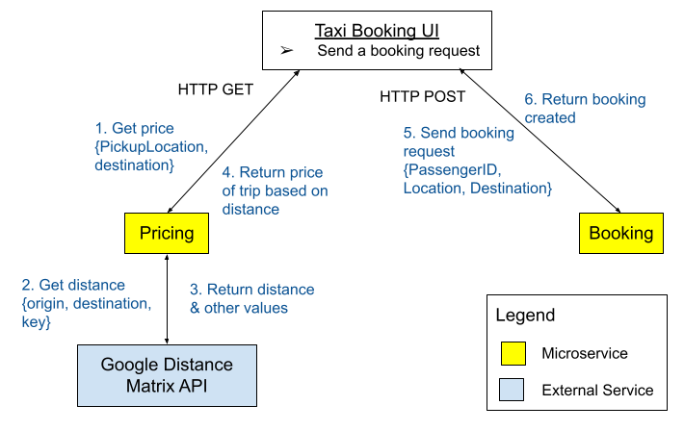  
Sample - Microservice Interaction Diagram*

*[Write-up of this user scenario(s) with reference to the Microservice Interaction Diagram(s).]   
(Note: the sample diagrams and descriptions in this template are for the purpose of illustrating their format; they may not be the optimal design for the scenario.)*

e.g. Send a booking request:

1. Passenger starts the booking request by clicking on a button on the UI, then the UI invokes the Pricing service via HTTP GET to get the price quotes.
2. Upon receiving a UI request, the Pricing service invokes the external Google Distance Matrix API to calculate the distance of the potential taxi trip.
3. The Google API returns the calculated distance back to the Pricing service.
4. The Pricing service calculates the prices based on distance and returns the price quotes back to UI.
5. The UI then, upon user confirmation, invokes the Booking service via HTTP POST to add a new booking.
6. The Booking service saves the booking details into the Booking db, then returns a status code with the booking details back to the UI.

### External Services

*[This is where you put in the details of any external service(s) that are* ***used in this User Scenario ONLY****]*

| Service Name | Description of the functionality | Link to external web pages that describe the detailed inputs/outputs |
| --- | --- | --- |
| *Google Distance Matrix API* | *Obtain the distance in km between two points for the use of price calculation for a Taxi trip.* | [*https://developers.google.com/maps/documentation/distance-matrix/start*](https://developers.google.com/maps/documentation/distance-matrix/start) |

### Beyond the Labs

*[List, describe and justify the things you have done that are not taught in the labs* ***for this User Scenario only (if any)****.]*

1. …

*…*

If Nil for this user scenario, no need to have this subsection.

## [User Scenario 2]

| *Figure 2a - Get available bookings* | *Figure 2b - Accept a booking* |
| --- | --- |

*[Write-up of this user scenario(s) with reference to the Microservice Interaction Diagram(s).]  
(Note: the sample diagrams and descriptions in this template are for the purpose of illustrating their format; they may not be the optimal design for the scenario.)*

e.g. Taxi driver uses UI to find a booking

**Figure 2a**

1. Taxi driver uses UI to find a booking request. The driver uses the UI to invoke the Booking service, via [GET] /booking/open to get all open bookings.
2. Return all bookings that are currently with the status = open. UI displays all bookings and driver selects a specific one

**Figure 2b**

1. Triggers UI to invoke Accept Booking complex microservice, [POST] /accept booking/{bookingID}, to orchestrate the accept booking process.
2. The Accept Booking microservice invokes Booking microservice, [PUT] /booking/{bookingID}, to update the status of the booking
3. Booking microservice returns the updated booking information (e.g. passenger ID).
4. The Accept Booking microservice invokes Passenger microservice, [GET] /passenger/{passengerID}, to obtain Passenger information.
5. Passenger microservice returns the passenger information (e.g. contact details).
6. Accept Booking microservice sends a message {passengerID, driverID, phone} with the routing key passenger.notify to a topic message exchange. SMS service will receive the message based on the binding key *.notify and send a SMS to the passenger.
7. The Accept Booking service upon receiving passenger information returns the confirmation of the booking to the Taxi Driver UI.

### External Services

*[This is where you put in the details of any external service(s) that are* ***used in this User Scenario ONLY****- exclude those that have been mentioned in the previous user scenarios.]*

| Service Name | Description of the functionality | Link to external web pages that describe the detailed inputs/outputs |
| --- | --- | --- |
| *twilio SMS* | *…* | *…* |

### Beyond the Labs

*[List, describe and justify the things you have done that are not taught in the labs* ***for this User Scenario only (if any)****.]*

1. …

*…*

If Nil for this user scenario or the beyond-the-labs has been mentioned in the previous User Scenario(s), no need to have this subsection.

## 

## [User Scenario n]

…

# 

# Remaining Beyond the Labs not covered above

*[List, describe and justify beyond-the-labs component(s) that are not already mentioned in the previous User Scenarios section.]*

e.g.

* Use an API gateway, e.g., KONG or others, in a reasonable way for the scenario.
* Use multiple programming languages and/or frameworks to demonstrate that microservices can be developed independently.
* Use GraphQL, gRPC, or other communication technologies in a reasonable way beneficial for the scenario.

# 

# Appendix - Technical Overview Diagram(s) or SOA Layer Diagram(s)

(The appendix is not counted towards the page limit. It is not explicitly graded, but will be used to verify against your solution as described in the report if required.)

*[If the database portion for any microservice cannot fit into one diagram, have a separate diagram and refer to it]*

*…*

# Appendix - API Docs

(The appendix is not counted towards the page limit. It is not explicitly graded, but will be used to verify against your solution as described in the report if required.)

*(You may follow the format used for* [*the sample API docs*](https://drive.google.com/drive/folders/1pMu97ovCRkCXtc-Po6G91U83iHyU6WsM?usp=sharing) *in our labs, or use Swagger to generate the API docs and export the* apispce.json *files and submit them in your project’s zip file.)*

Accept booking; HTTP-based API

Booking; HTTP-based API:

Pricing: HTTP-based API:

Passenger: HTTP-based API

SMS: AMQP-based API

*For the alternative design using AMQP request-and-reply*

Booking: AMQP-based API:

Passenger: AMQP-based API:

# Appendix - Technical Contribution Table

E.g. coding of feature X, deployment, configure database, etc.

| **Name** | **Contributions** |
| --- | --- |
| *E.g. Chris Poskitt* | *E.g. Coding of Place Order, Order microservices, and Kong API Gateway configuration for all microservices.* |
|  |  |
|  |  |
|  |  |